**ReadMe Document:**

**Project Name:**

The name of the web application/website is Agriculture.

**Instructions:**

This document provides important information about the project. Before you move on to attempting to run the project please read the following information below.

**Prerequisite:**

Install Visual Studio 2019 or 2022 to be able to run the application.

Install SQL Server Management Studio (SSMS).

**Usage:**

Instructions on how to compile the software:

**Step 1:**

* Install the folder from GitHub.
* Extract the folder you downloaded.
* Inside the unzipped folder, you will find a file named database bacpac(This is where you will get the database scripts).

1. Open SQL Server Management studio.

* Connect to your SQL Server instance.
* Right-click on the Databases node in Object Explorer and select Import Data-tier Application.
* Follow the wizard to import the database bacpac file and restore the database.

1. Open Visual Studio.

* Navigate to File->Open->Project/Solution.
* Open the project file (.sln) from the unzipped folder.

1. Recreate the Entity Data Model ( EDO Model):

* In Solution Explorer, locate the existing EDO Model.
* Right-click on it and select Delete.
* To recreate the model, right-click on the project in Solution Explorer, select Add -> New Item -> ADO.NET Entity Data Model.
* Follow the wizard to generate the model from the database you restored in SSMS.  
  During the wizard setup, ensure the new connection name is set to Agricultural_Entities.
* Make sure to update the connection string to point to your database.

1. Run the Project:

* Once the EDO Model is recreated, build the project to ensure everything is configured correctly.
* Run the project to verify that it connects to your database and works as expected.

**Step 2:**

How the website Functions and looks:

**Signing-In as Employee:**

**Sign-Up Page:**

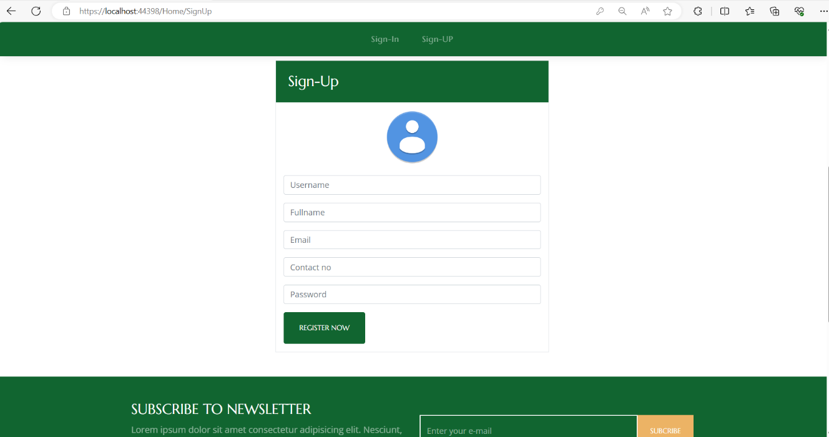

The user will be required to Sign-up before having access to information inside. They will have to fill in the username, full name, email address, contact information and password then press on the button below to register.

**Login Page**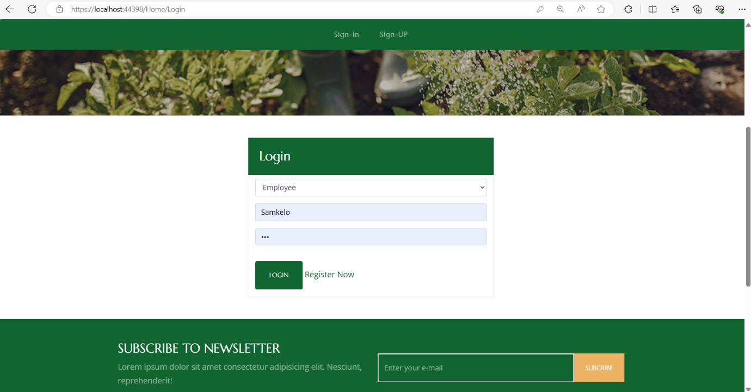

When the user is done signing up, they will then be required to login using the same email address and password they used when signing up. The user has an option to sign in as an employee or farmer. In this case the user chose the Employee role.

**Home Page:**

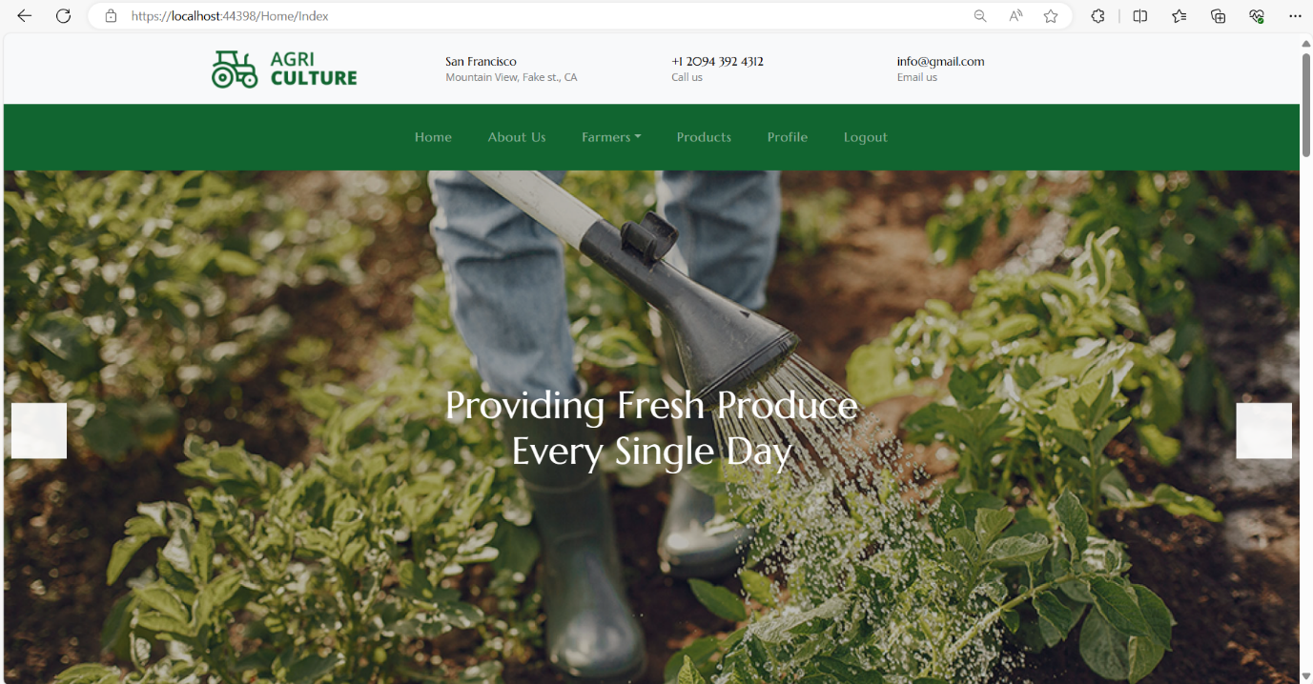

When the employee has successfully signed in the homepage will be the first page they see as it is a landing page.

**About Page:**

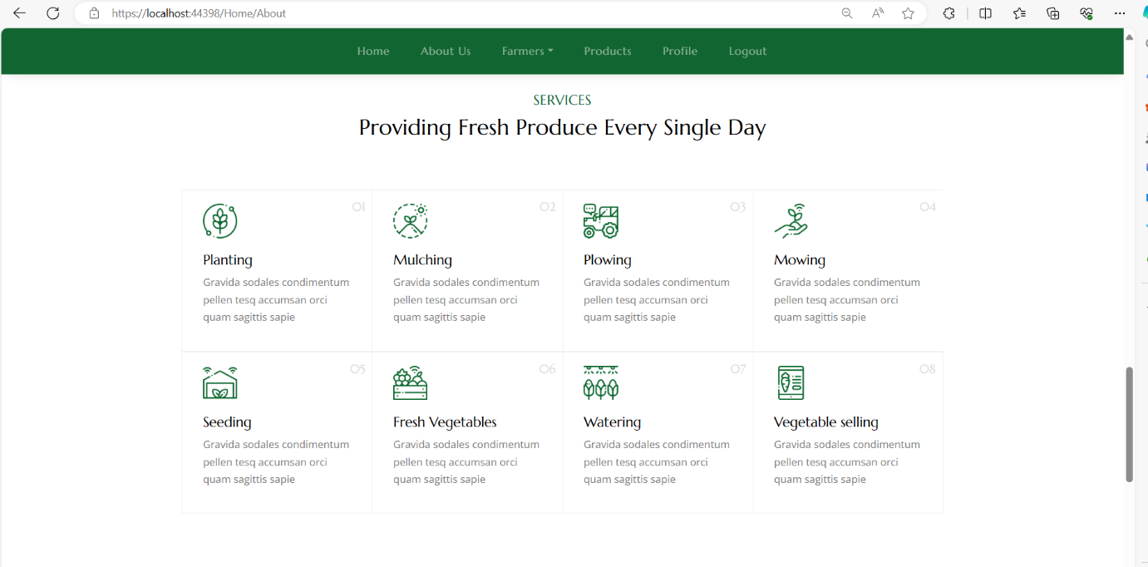

On this page the employee will get to view all the services the farmers have.

**Farmers Page**

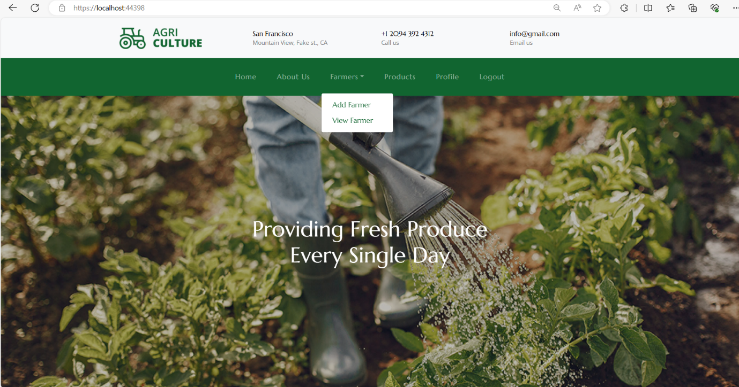

When the user is signed in as the employee this is what they will see as an employee. The employee can add new farmer profiles, view all products from specific farmers, and use

filters for product searching.

**Add New Farmer**

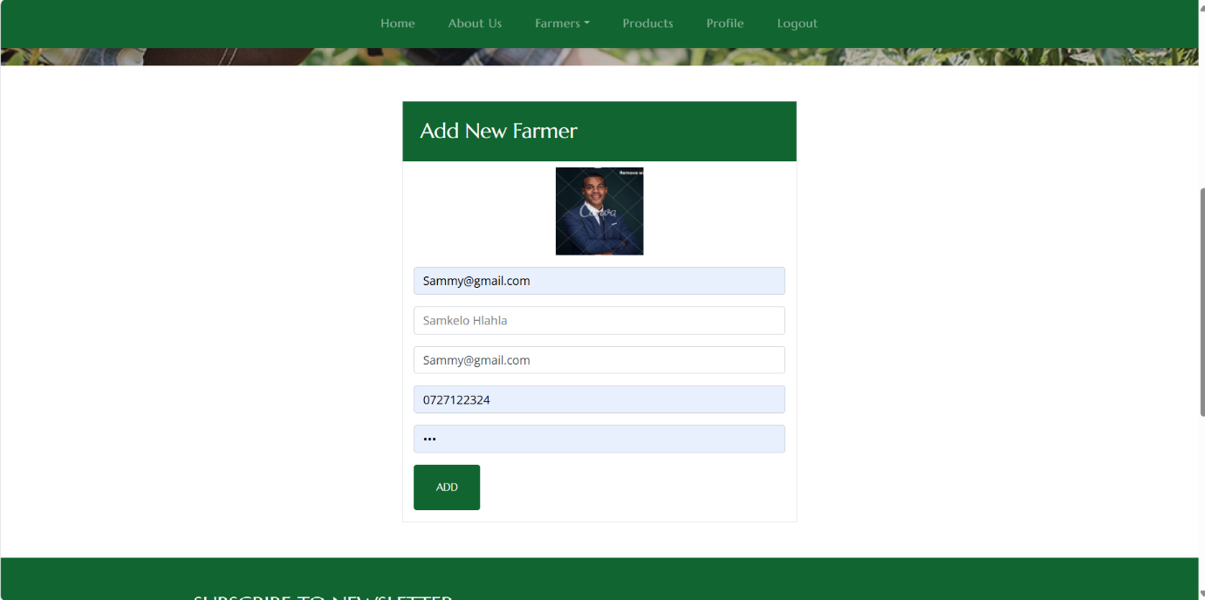

This is how the employee is going to add a new farmer, they have an option to also upload an image of the farmer by simply clicking on the person icon and then will be required to choose and upload an image.

**View Farmers**

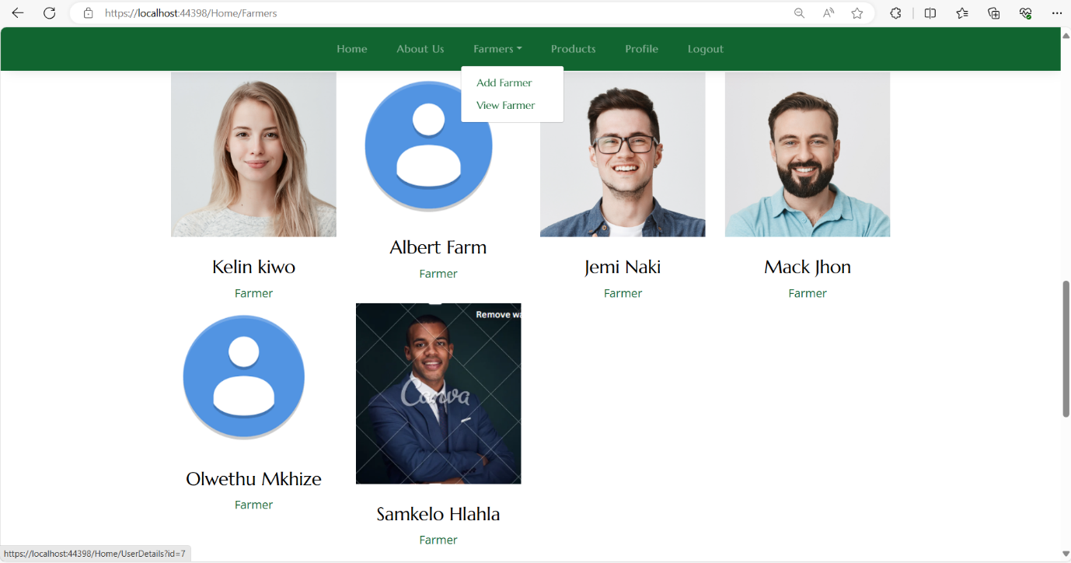

When the employee chooses to view the farmer, a list of all the farmers and their pictures will be displayed under “Meet the Team”.

**Products Page**

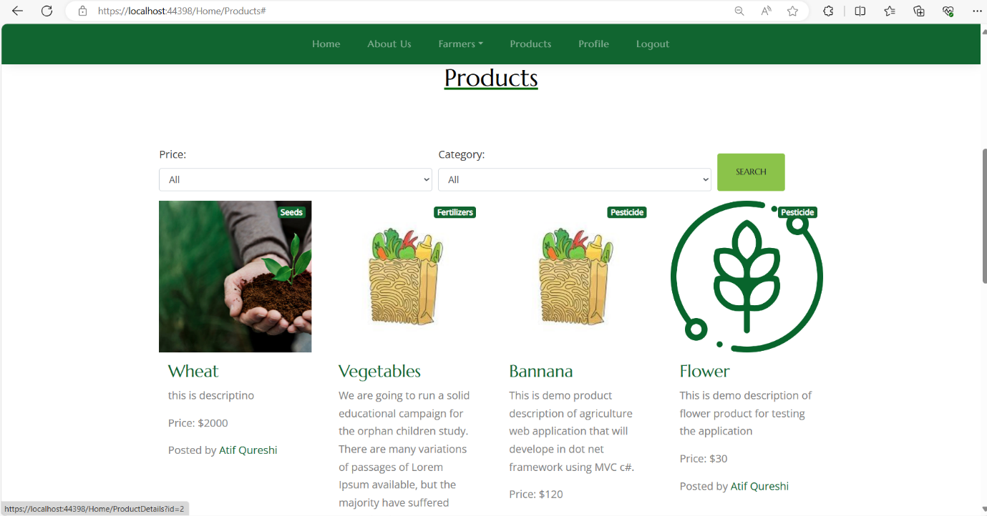

On this page the employee has a capability to view and filter a comprehensive list of products from any farmer based on criteria such as price and product type. Each product uploaded by a farmer will appear here and at the bottom will showcase the name of the farmer that uploaded the product. Employee also has the ability to search on and product using the search feature on the to right.

**Profile Page**

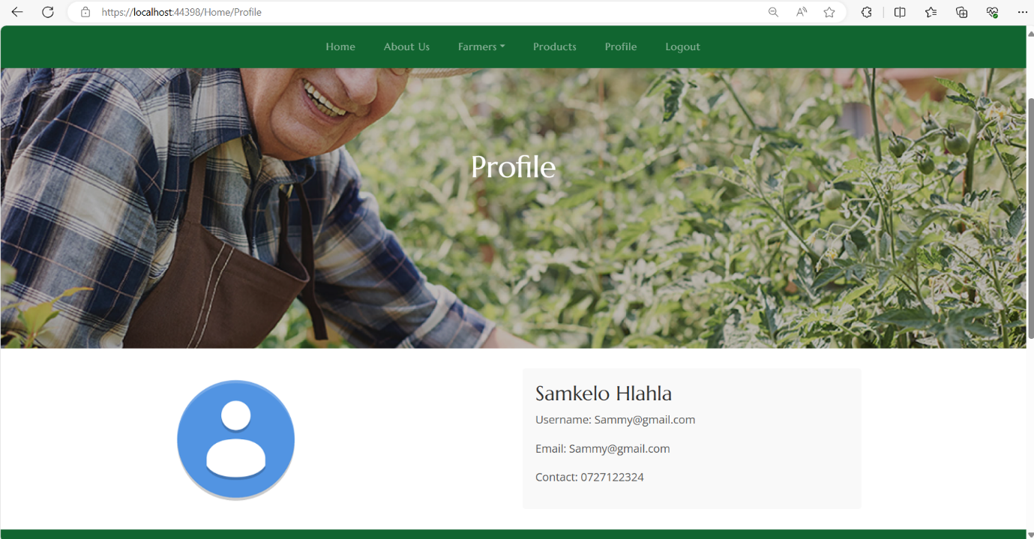

This page will showcase a specific employee’s profile that is currently signed in and all their details.

**Signing-In as a farmer:**

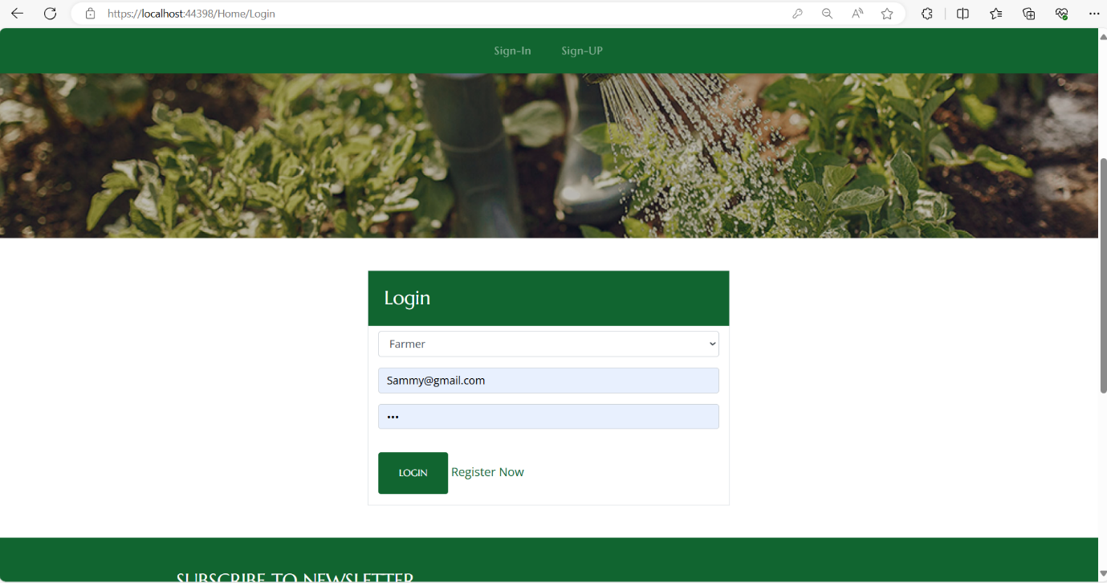**Login Page:**

When the user is done signing up, they will then be required to login using the same email address and password they used when signing up. The user has an option to sign in as an employee or farmer. In this case the user chose the Farmer role.

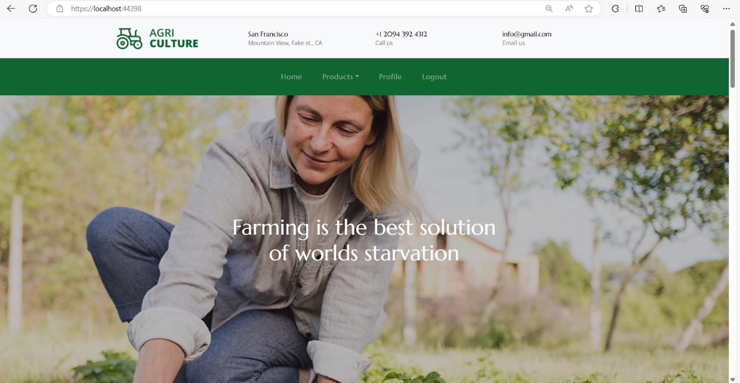**Home Page:**

When the farmer has successfully signed in the homepage will be the first page they see as it is a landing page.

**Product Page:**

**Add a new product:**

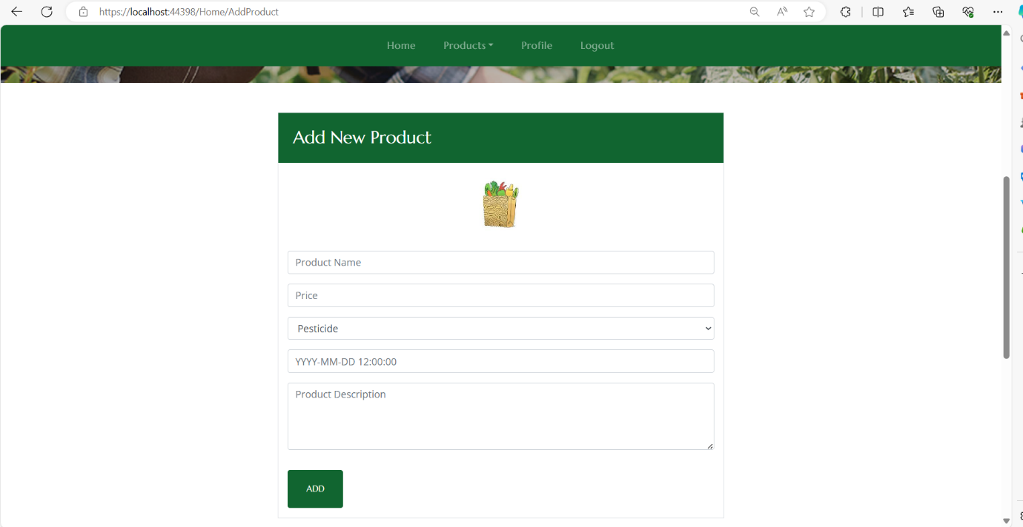

On this page the farmer can add products to their profile and view their own product listings. They can enable product addition feature where farmers can add new products with details like product

name, price, category, and production date, production time and product description as shown above.

**View Product:**

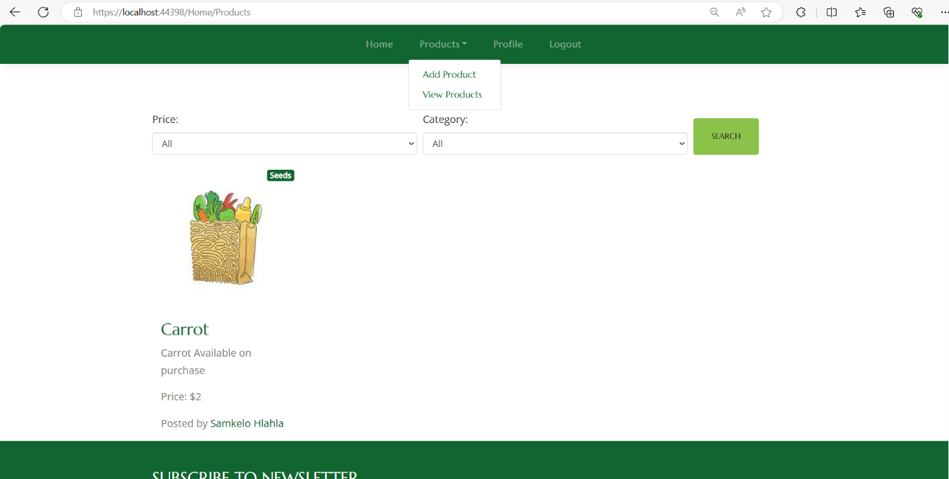

When the farmer clicks on the view products section this is what they will see. They will see what they have uploaded, and it will show who posted the product. The farmer can also search for products they want to see by simply clicking on the search button.

**Profile Page:**

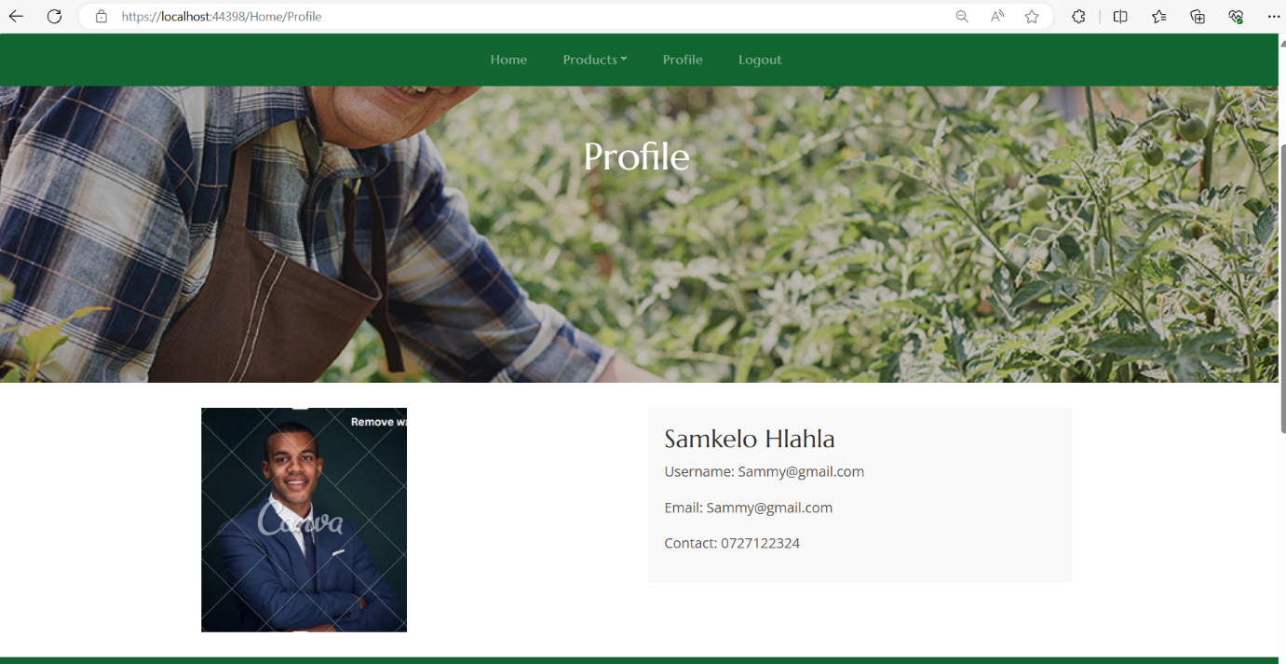

This page will showcase a specific farmer’s profile that is currently signed in and all their details.

**Running the Software:**



Press the green IIS Express button on the top on Visual Studio toolbar or press F5 or Ctrl+F5. Then Visual Studio attempts to build and run the code in your project.

**Contact:**

Information on how to contact the developer:

**Name:** Olwethu Dlalisa

**Contact ME:** 0677514765

**Email address:** Olwethudlalisa7@gmail.com